

Design of an AM Radio Receiver

ECSE 434

Micro Electronics Lab

Final Report

Group # 08

Sharhad Bashar, *260519664*

Chrouk Kassem, *260512917*

Zixuan Yin, *260502051*

Wednesday, 2nd December 2015

Table of Contents

1. INTRODUCTION 4

2. BASEBAND AMPLIFIER 5

i. Theory 5

ii. EXPERIMENT 6

a. Frequency Response 6

b. Variable Resistance versus Gain 6

c. Input Resistance 7

iii. Discussion 7

3. DEMODULATOR 8

i. Theory 8

ii. Experiment 9

iii. Discussion 9

4. CLASS A OUTPUT STAGE 11

i. Theory 11

ii. Experiment 12

iii. Discussion 12

5. PREAMPLIFIER 13

i. Theory 13

ii. Experiment 14

iii. Discussion 14

6. AM RECEIVER 15

i. Theory 15

ii. Experiment 16

iii. Discussion 18

7. CONCLUSION 19

8. LIST OF FIGURES 20

9. LIST OF TABLES 20

10. Appendix 21

# INTRODUCTION

Wireless technology has become intertwined with our daily activities. An important component of a wireless system is front-end analog receiver, made of a transmitter and receiver. Signals are transmitted and received through electro magnetic (EM) emissions. The baseband signal has a low frequency range (0 – 20 KHz). To efficiently transmit them, a carrier signal with high frequency is often used. This process is known as signal modulation.

In this lab, we will build an AM radio receiver to receive these signals. The receiver is made of six main components, as shown in the diagram below:

1. Antenna
2. Preamplifier
3. Demodulator
4. Baseband Amplifier
5. Output Stage
6. Speaker

Due to the fact that most information-carrying signals are modulated so it is more efficient to transmit, the resulting waves are typically very low in amplitude. Thus, the wireless AM receiver should be able to do a couple of things:

* Filter out unwanted signals
* Amplify the low amplitude signal
* Demodulate the signal to recover the baseband envelope
* Drive a large current through

The four stages along with the antenna and speaker work together to receive these modulated signal and process it and outputs the information inform of radio signals which we can hear through the speaker.

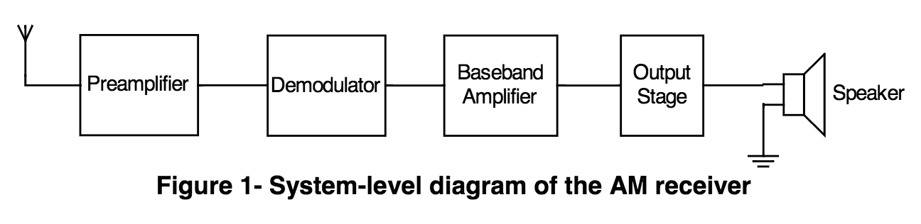We will go into further detail outlining the design theory, experimental results and relevant discussion for each of the four stages.

Figure .1: System-level diagram of AM receiver

# BASEBAND AMPLIFIER

## Theory

The experiment begins by designing the third stage of the circuit, which is the baseband amplifier. The incoming signal has been pre-amplified and demodulated. Since the demodulator has a gain of less than one, then it will have reduced amplitude. This stage is used to achieve an in-band gain of 150V/V of the incoming signal. Op-Amp model TL084 is used. The topology is based on a non-inverting amplifier. This stage also includes a variable resistor that manually varies the gain. The potentiometer is used as volume control in the final circuit of the AM radio receiver.

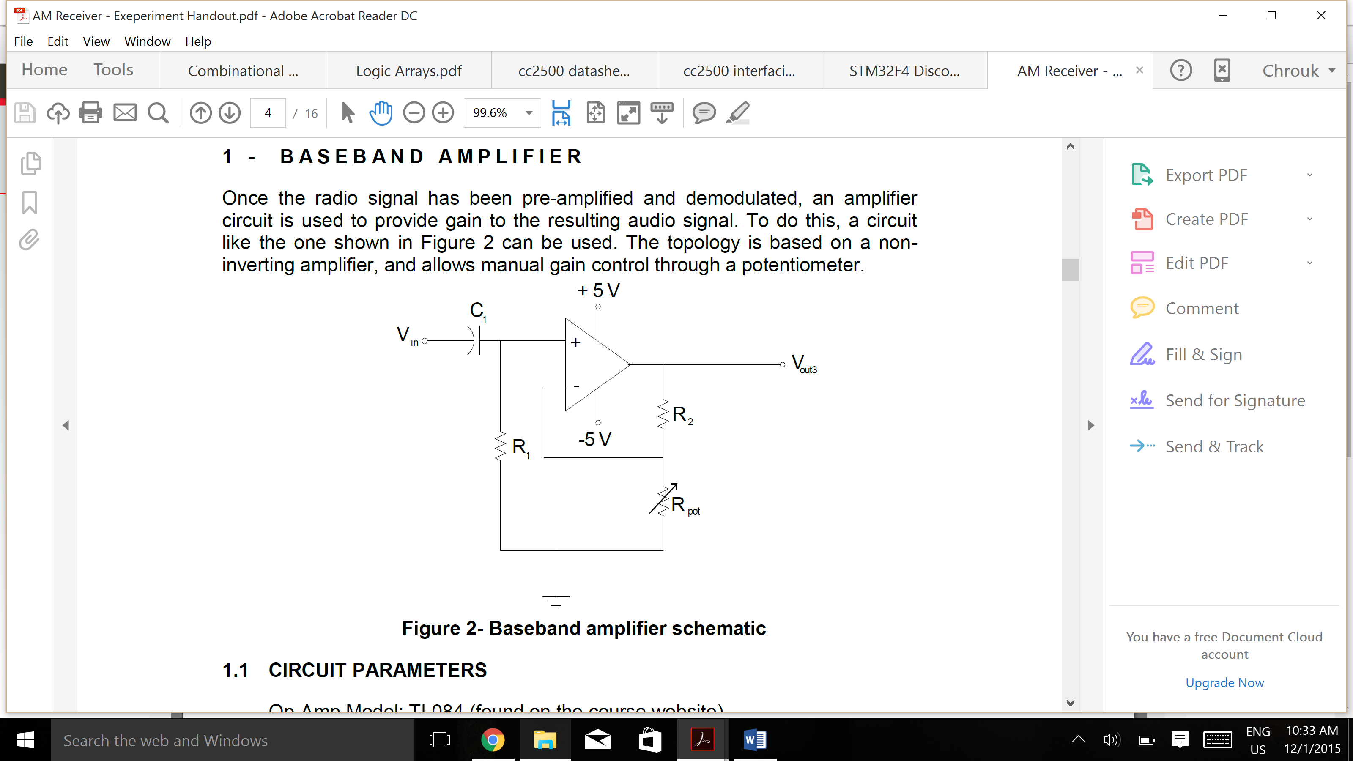

Figure 2.1: Baseband amplifier circuit

Capacitor, C1, is used to remove the DC component from the incoming demodulated signal. Capacitors act as an open circuit at DC frequencies, thus blocking the DC components of incoming signal. The resistor, R1, serves as a path for the input bias current to flow to ground. Resistors, R2 and Rpot, are used to control the gain. The gain, Av, of this circuit not including capacitor C1­ is given by the following equation

Av1 = = 1 + $\frac{R2}{Rpot}$ (2.1)

Including the capacitor, C1, changes the gain to

Av2 = (1 + $\frac{R2}{Rpot}$) (2.2)

This shows that the gain with capacitor reduces by a factor of $\frac{jwC1}{jwC1+ 1/{R1}}$.

Assuming an ideal op-amp with an infinite input resistance and zero output resistance, the input resistance of this stage is given by

Rin|baseband = R1 || Rin|opamp = R1 = 150kΩ (2.3)

The output resistance of this stage is given by

Rout|baseband = (R2 + Rpot) || Rout|opamp­ = 0Ω (2.4)

## EXPERIMENT

### Frequency Response

Using the TL084 op-amp model, the baseband circuit shown in Figure 2.1 must be built. The following parameters are given:

VCC = +5V R1 = 150k

VEE = -5V Rpot = 0 – 10kΩ

C1 = 1µF

The circuit is assembled on breadboard with value of R2 equal to 180kΩ. The signals are observed using the oscilloscope. The overall frequency response of the amplifier is plotted. The frequency was varied from 1Hz to 100 kHz. The input voltage fed into the circuit was 36mV using a voltage divider. The gain is 153.33V/V. The upper 3dB cutoff frequency is 30 kHz and lower 3dB cutoff is 2Hz. Table 10.1in appendix shows the points taken to plot graphs. The frequency response plots are shown below in Figures 2.4 and 2.5:

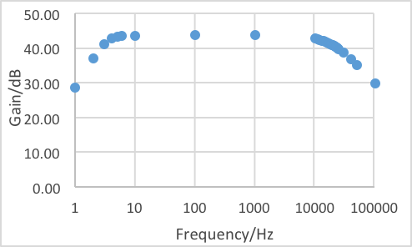

Figure .2: Frequency response for gain in V/V

Figure .3: Frequency response for gain in dB

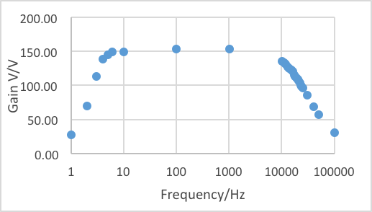

### Variable Resistance versus Gain

The relation between Rpot­ and gain is plotted in the assembled circuit. Tables of both plots are on the appendix. The potentiometer is varied from 470Ω to 10 kΩ. The plot of gain in V/V and dB versus Rpot can be seen in Figures 2.4 and 2.5 respectively:

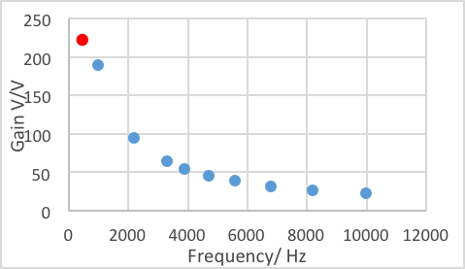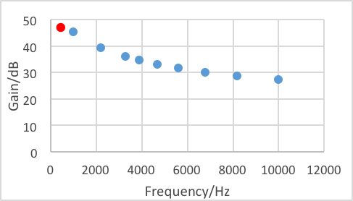

Figure .5: Plot of gain in dB versus variable resistance

Figure .4: Plot of gain in dB versus variable resistance

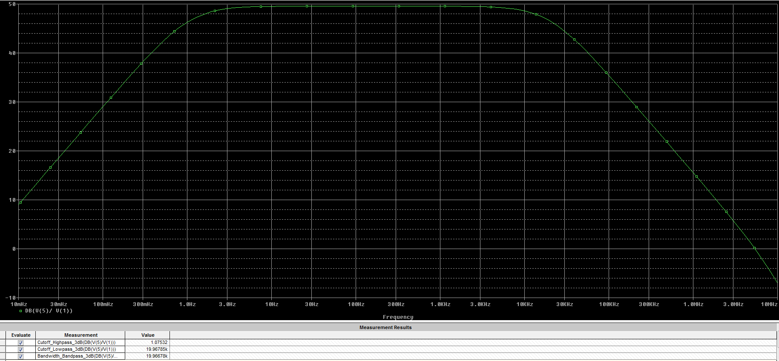

*Figure 2.6: Spice Simulation for base band amplifier*

These plots clearly prove that relation between Rpot and gain is inversely proportional.

### Input Resistance

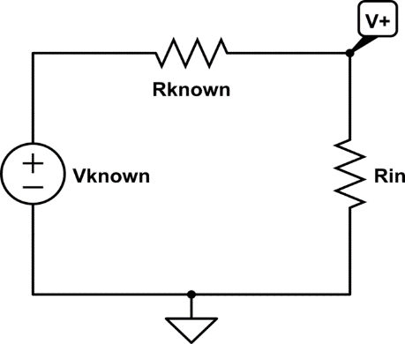The input resistance of circuit must be measured. In order to measure the input resistance, another known resistor, Rknown, is added in series to the amplifier stage. The input voltage of the circuit is known, Vknown. The voltage, V+, is measured using a voltmeter/oscilloscope. Using voltage divider rule, the input resistance can be calculated by:

V+ = Vknown (2.5)

Finding for Rin:

Rin = V+ (2.6)

Figure 2.7: Equivalent circuit for measuring input resistance

An input voltage, Vknown, of 372mV was fed into the circuit. A known resistance, Rknown, of 100kΩ was connected to the circuit in series. V+ measured 226mV. Putting these values back into equation 2.4 gives a value of Rin|baseband equal to 155kΩ.

## Discussion

The value of R2 was found using the theoretical gain equation, with Rpot at 1kΩ for an in-band gain of 150V/V. Selecting Rpot to be 1kΩ, using the gain equation 2.1, R2 theoretical is calculated to be 141.55-156.45kΩ to the nearest 5% accuracy. This range was used in SPICE simulation to find R2 that gives the desired results. Table 2.1 shows the different values used in SPICE simulation and experimentally:

Table 2.1: Comparison of simulated and experimental results of baseband amplifier

|  |  |  |
| --- | --- | --- |
|  | **SPICE Simulation** | **Experimental** |
| **R2** | 156 kΩ | 180 kΩ |
| **Rin|baseband** | 150 Ω | 155Ω |
| **Mid-Band Gain** | 149.333V/V | 153.33V/V |
| **Low 3-dB frequency** | 1.07532 Hz | 2 Hz |
| **High 3-dB frequency** | 35.96785 kHz | 30 kHz |
| **Bandwidth** | 35.96678 kHz | 28 kHz |

There is discrepancy between the simulated (shown above) and experimental values. Difference in bandwidth can be a result of the parasitic capacitance in the op-amp that may not be taken into account in simulation. The probes of the oscilloscope and generator can load the circuit affecting gain of the circuit. The op-amp model in SPICE may not have exact gain in experiment, which is the case in reality. This can also affect the gain of the circuit. This is a 10% discrepancy, which is acceptable.

# DEMODULATOR

## Theory

Demodulator is the second stage of the AM Receiver. Demodulator reconstructs the original baseband signal by detecting the positive envelope of input signal (received AM signal). The diode-resistor configuration represents a half-wave rectifier that filters the upper half of the circuit. By using a capacitor, the envelope of the circuit can be detected.

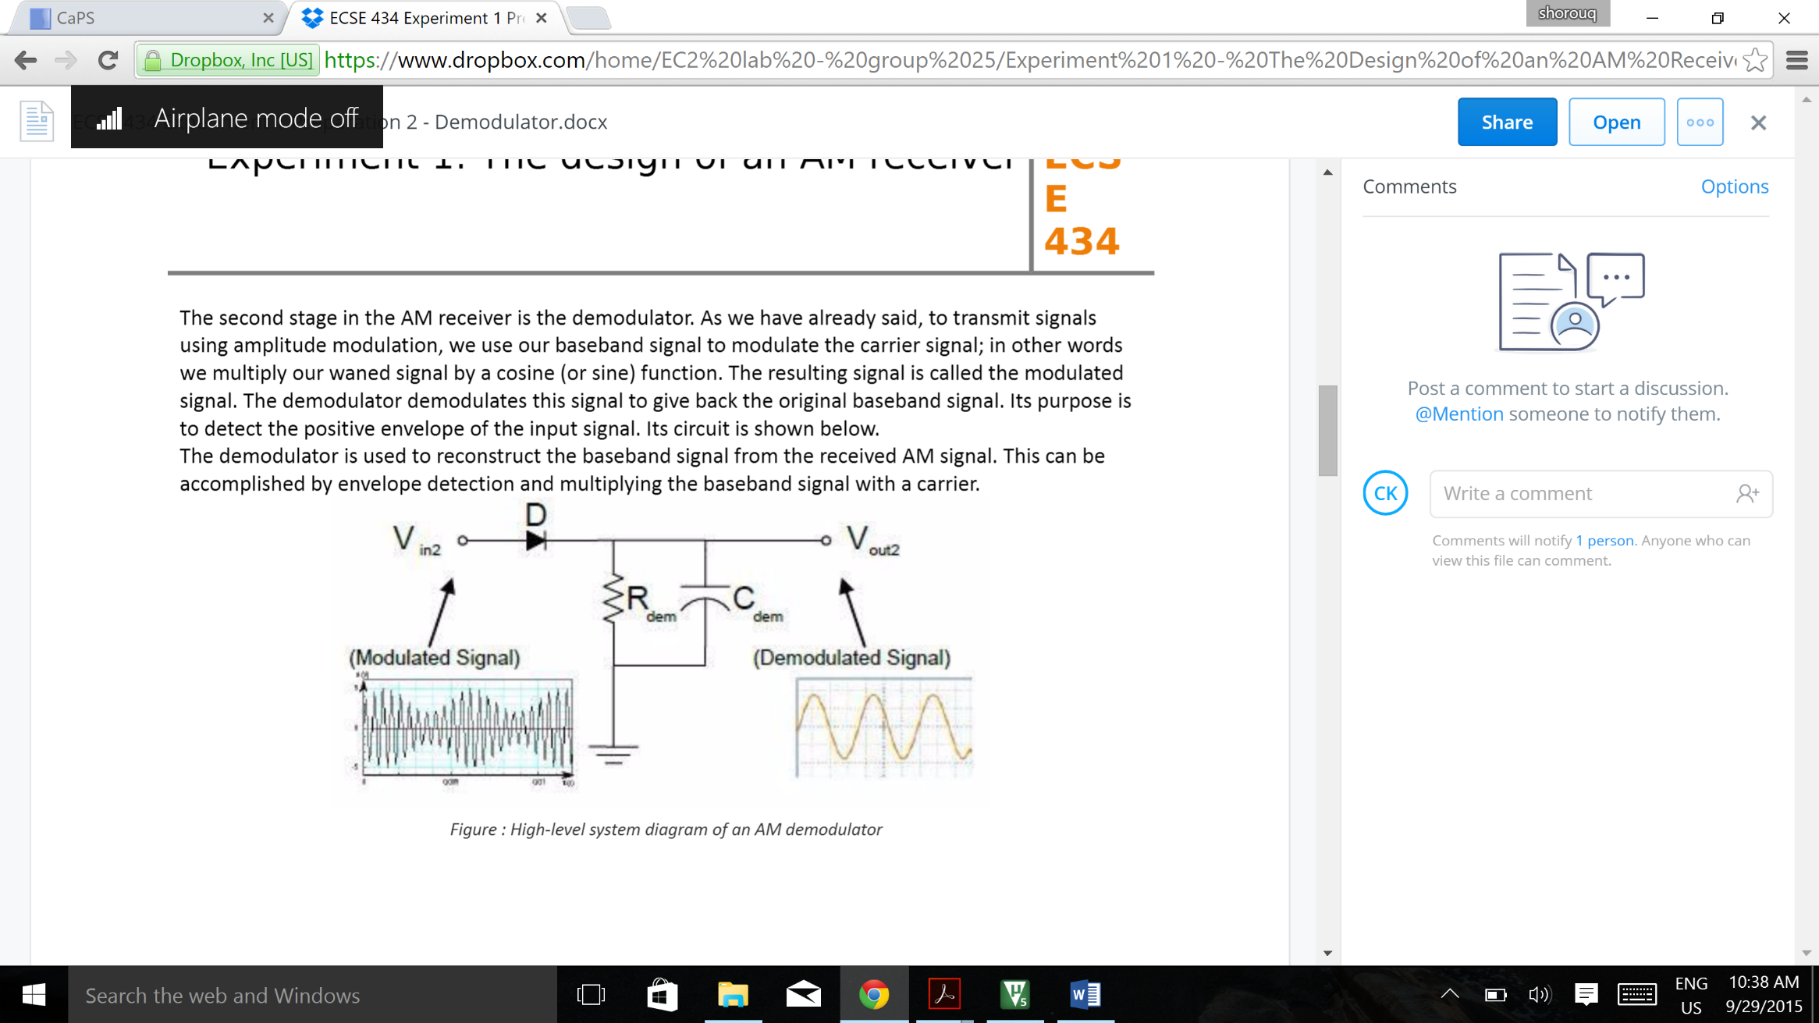

Figure 3.1:High-level system diagram of AM demodulator

The discharge and charge of capacitor, Cdem, through the resistor, Rdem, detects the envelope of the output signal. However, the discharge rate must be limited. The time constant, τ = Cdem*Rdem, must be:

* Greater than period of carrier signal to minimize the ripple in output signal. It must also be
* Less than period of baseband signal to ensure that the rate of voltage drop is not too low and it follows envelope of input signal.

This gives the following inequality:

τcarrier < τRC < τbaseband (3.1)

In term of frequencies, it can be expressed as:

fbaseband < fRC < fcarrier (3.2)

Knowing that the wanted baseband signal is in the 0-20kHz range, and the unwanted carrier signal is in the 200 kHz – 1.2 MHz range. Knowing fRC can be expressed as $\frac{1}{\sqrt{2ΠRdemCdem}}$.

20 kHz < $\frac{1}{\sqrt{2ΠRdemCdem} }$ < 200 kHz (3.3)

The DC point at the inputs of the demodulator need to be high enough such that the diode is on at all peaks, it should satisfy the following inequality:

VDC > - (Vcarrier – Vbaseband - 0.3v) (3.4)

## Experiment

The circuit was simulated in Pspice and the resulting plot was produced, as shown in figure 3.5. The circuit was assembled with an input voltage of 3.6V. The values used experimentally for Cdem was 103nF. The value of R­dem used was using two resistors in parallel to give a resistance of 1.364 kΩ.

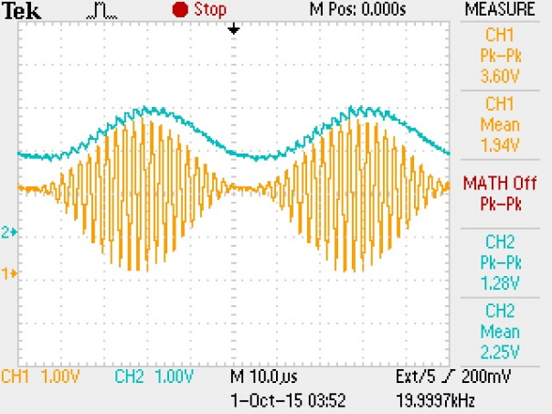The waveform of the input signal and demoduolated output signal can be seen in Figure 3.2. The gain of the demodulator versus the baseband frequency was taken by varying the baseband frequency from 1 kHz to 20 kHz. The table showing points taken can be found in Table 10.2 in appendix. The plot of the gain is shown in Figure 3.3. The gain is 0.367V/V.

The gain of demodulator versus the carrier frequency was also taken by varying the carrier frequency from 200 kHz to 1200 kHz. . The table showing points taken can be found in **Table** in appendix. The plot of the gain is shown in Figure 3.4. The gain is 0.344V/V.

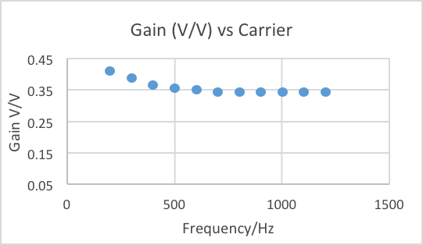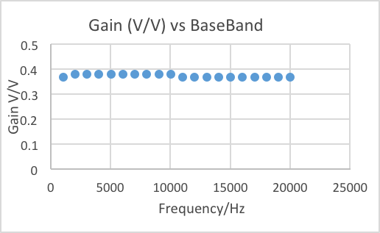

Figure .3: Gain versus baseband frequency plot

Figure .4: Gain versus carrier frequency plot

Figure .2: Waveform of input signal versus the output signal

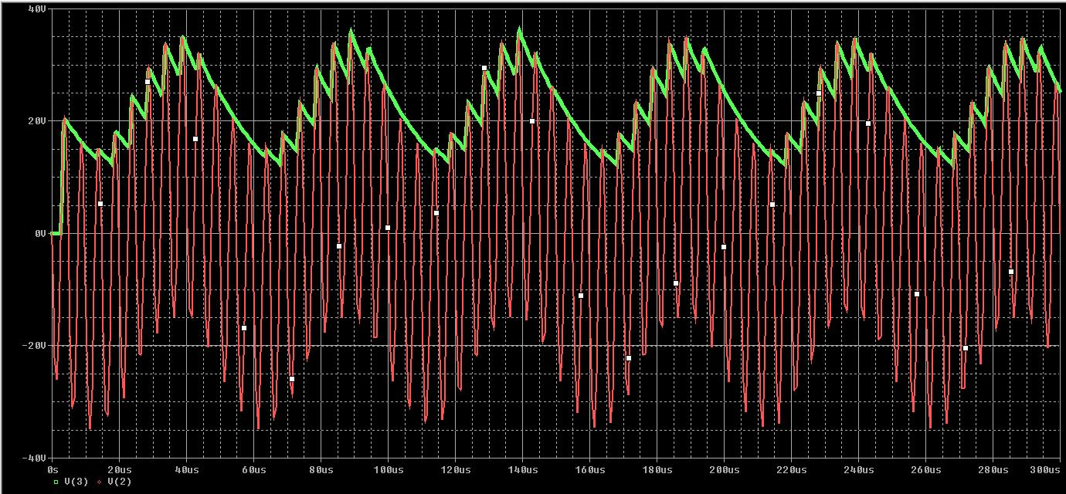

Figure .: Pspice simulation for Demodulator

## Discussion

The table below compares simulated and experimental data for the demodulator.

Table 3.1: Comparison of simulated and experimented values of demodulator

|  |  |  |
| --- | --- | --- |
|  | **SPICE Simulation** | **Experimental** |
| **Rdem** | 10 kΩ | 1.367 kΩ |
| **Cdem** | 0.934 nF | 103 nF |
| **Gain(baseband frequency)** | 0.984 V/V | 0.367 V/V |
| **Gain(carrier frequency)** | 0.896 V/V | 0.344 V/V |

# There are clear differences between the values for Rdem and Cdem used in SPICE simulations and experimentally. The value of Rdem was assumed theoretically, and then Cdem was found accordingly. However, experimentally there was no 0.934nF capacitor and least value of capacitance available is 10nF. Thus the value of capacitance was first chosen and Rdem was found accordingly.

# The gain for both responses must be less than one. The diode is ideally considered as a short circuit in small signal analysis. However, in real life the diode has a small resistance. This acts as voltage divider with Rdem. Changing the voltage charged and discharged by Cdem. This can be the result of the differences seen in gain between simulations and experimentally. It must also be noted that the Rdem value experimentally is much smaller than one used in SPICE simulation, thus it will be more affected by voltage divider of small resistance of diode. This can be reason is smaller gain experimentally.

# The experimental data for the varied baseband signal frequency and the carrier signal frequency supports the fact that the gain response is approximately constant, having wide bandwidth. It is highly desirable to have a wide bandwidth when hearing a certain channel, to pass all the frequencies at the same gain. The varying baseband signal ensures that the output is stable at the range of human hearing (0 - 20 kHz). The varying carrier signal ensures that the output is stable for all the channels in the range of 200 - 1200 kHz.

# CLASS A OUTPUT STAGE

## Theory

Power amplifier is the final stage of the AM receiver. This stage serves to amplify the low current from baseband amplifier, in order to power the speaker and make sound. It is an emitter follower biased at a high current. T5 and T6 can be seen as a current source.

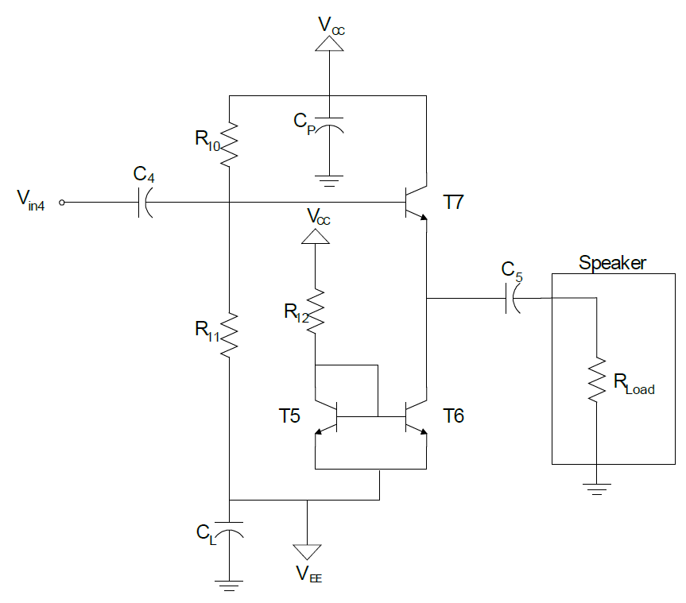

Figure 4.1: Circuit schematic of Class A output

Maximum output current at the load is determined by ${Vcc}/{R12}$. The circuit should be biased such that DC point at the load is 0V, so maximum voltage swing can be achieved. The boundaries of the voltage swing are shown below. Input resistance of this stage should be high as possible in order to decrease the loading effect from previous stage. It has a voltage gain of unity theoretically, within the output swing.

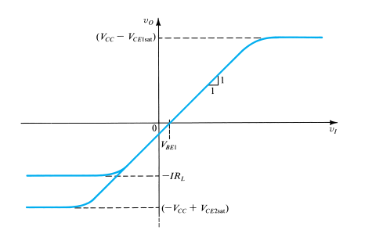

Figure 4.2: Graph showing cutoff voltages of a transistor

## Experiment

Once the power amplifier starts working, transistors will start to heat up, which will further increase the current until the transistors burn. To avoid this, we put RE of same value at the emitters of T5 and T6, decreasing the Vbe across transistors. Another thing we did is that we put two transistors in parallel with space between as use the pair as one transistor. They will share the current flow and thus, avoid transistors getting burnt.

Here are the resistor values in our final circuit: R10=15kΩ, R11=100kΩ, R12=82Ω, RE= 10Ω, RL=10Ω. The frequency analysis of small signal model (200mV pk to pk) and large signal model (1V pk to pk) was measured. Plots are shown below. There is some consistency in the results.

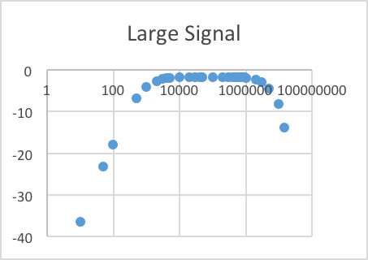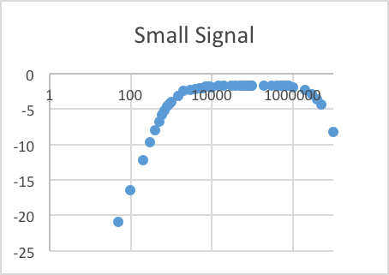

Figure .3: Small versus Large gain (dB)

Table 4.1: Small versus Large signal cutoff and gain

|  |  |  |
| --- | --- | --- |
|  | 3-db cutoff frequency | In-band gain |
| Small Signal | 750Hz-5MHz | 0.82 |
| Large Signal | 800Hz-5MHz | 0.8 |

Maximum voltage output is at 2.2V pk-pk, measured 10KHz, beyond that, the output start to get clipped.

## Discussion

Table 4.2: Spice versus Experimental values for class A output stage

|  |  |  |
| --- | --- | --- |
|  | SPICE Simulation | Experiment |
| R10 | 4.3KΩ | 15KΩ |
| R11 | 5.7KΩ | 100KΩ |
| R12 | 48Ω | 82Ω |
| RE | 47Ω | 10Ω |

When doing spice stimulation, we didn’t take loading effect from previous stage into consideration, the final values been used gives us a DC biasing the closest to 0.7 V. The difference mainly comes from loading effect.

Overall, we were able to build an output stage with a voltage gain of about 0.8 and swing of 2.2V for a 10 Ω load resistor. That’s good enough to power the speaker and make audio sound. One drawback of the circuit is the low power efficiency. Class A output stage can only achieve a maximum 25% power efficiency. Also the transistors still heat up after minutes of operation.

# PREAMPLIFIER

## Theory

The preamplifier is the first stage of the receiver. The input, connected to the antenna is sending in modulated signals. These signals are very weak and require amplification. The circuit below shows the baseband amplifier used for the receiver. The circuit consists of an LC tank, a Darlington pair and a cascaded common emitter amplifier. The inductor and capacitor are placed in a parallel configuration, acting as a band pass filter to filter out signals from unwanted frequencies. The cascaded amplifier amplifies the signal, while improving the speed of the circuit. It also works with the Darlington pair to ensure high impedance seen from the tank.

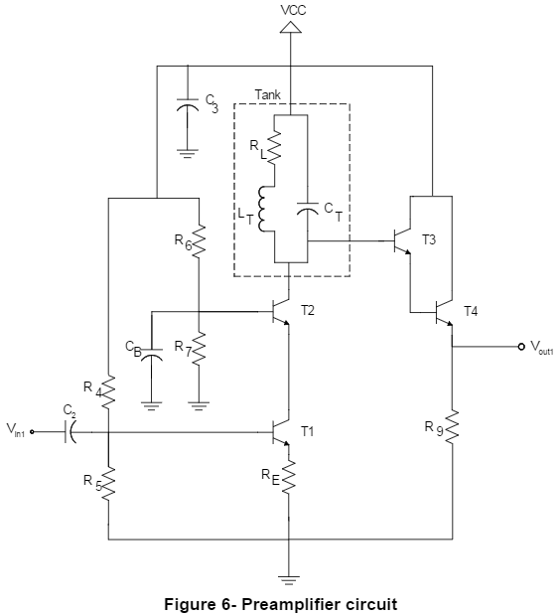

fres = 0.48 MHz

Figure .1: Preamplifier circuit

The impedance of the tank is maximal at resonant frequency, which was provided. The values for L and C were arbitrarily selected to satisfy the following equation:

$f_{res}= \frac{1}{2π\sqrt{L_{T}C_{T}}}$ (5.1)

We choose CT to be 100nF, and calculated LT to be 1.099 μH, for the given frequency of 480 KHz.

There are several resisters used in the design of the circuit. R4 and R5 are used to bias the input, and R6 and R7 are used to bias T2. RE is emitter degeneration resistor. Its main purposes are to increase the output resistance of the amplifier, control the gain and to stabilize the amplifier.

The capacitors in the circuit are used as decoupling capacitors for isolating and cancelling out the noise.

The size of the bandwidth produced by the preamplifier is inversely proportional to its efficiency and quality factor. Wide bandwidth decreases the frequency selectivity of the amplifier and gain of the amplifier. Therefore we could pick up signals in other bands. Narrow bandwidth makes the amplifier more selective with greater quality factor (Q), thus larger output resistance of tank. This in hindsight may cut off desired signal.

The gain of the circuit was set to be 50 V/V. The small signal gain can be calculated as the collector impedance divided by the emitter resistance of T1. The equation was derived as follows:

$A{}_{v}= \frac{R{}_{T}||{(β}^{2}\left(r_{e}+R_{e}\right))}{r_{e}+R_{e}}$ (5.2)

A buffer might also be used in this circuit. Buffer increases the base resistance of the output transistor. Higher base resistance minimizes the energy loss of the LC circuit, therefore giving the circuit a high Q-factor and low bandwidth.

## Experiment

Resistor values were calculated to ensure maximum voltage swing. The voltages at each node were selected to ensure all transistors were operational. The resistor values calculated are as follows:

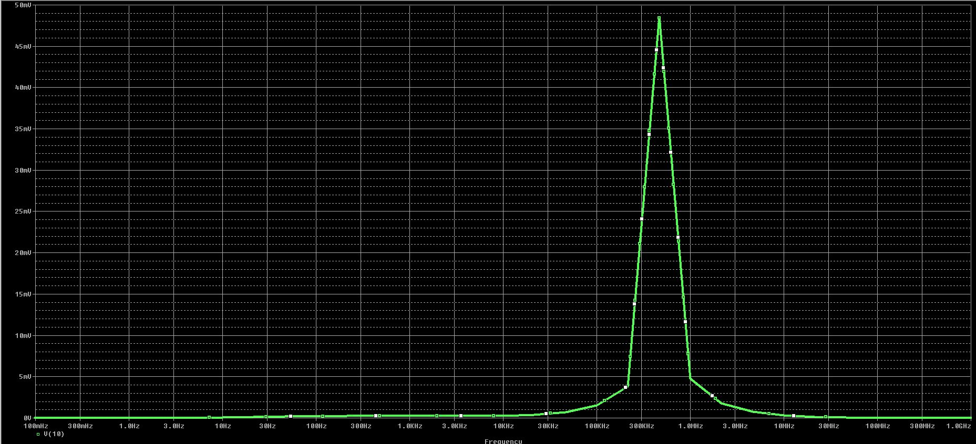

Figure .2: Spice simulation of Preamplifier

Table 5.1: Values used in Pspice versus experiment

|  |  |
| --- | --- |
| Spice | Experiment |
| RE = 10Ω  R4 = 2.8KΩ  R5 = 2.2KΩ  R6 = 2.5KΩ  R7 = 2.5KΩ | RE = 90Ω  R4 = 8.5KΩ  R5 = 0.5KΩ  R6 = 22KΩ  R7 = 22KΩ |
| LT = 1.099 uH  CT = 100 nF | LT = 820 uH  CT = 0.01 uF |

These values were used in a spice simulation of the circuit and a gain of approximately 50 V/V was achieved.

The circuit was assembled and simulated with a modulated signal as the input. A modulated signal was produced to match the given frequency, with a peak-to-peak value of 2 mV. The output voltages were measured, and used to calculate the gain. The graph below shows the result. Table 10.5 in the Appendix lists the measured Vout values.

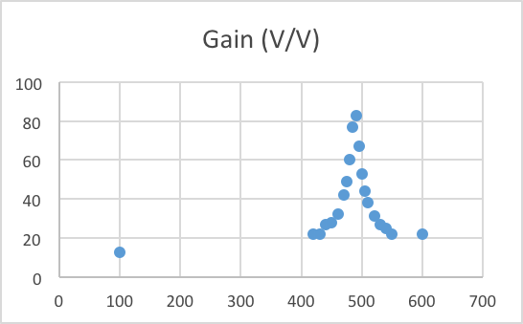

Figure .3: Voltage gain of preamplifier

From the graph we can see that the preamplifier has a gain of 88 V/V.

The peak occurs close to the resonant frequency, at a value of 483 kHz.

The circuit produced a low 3dB cutoff of 470 kHz and a high 3dB cutoff of 510 kHz

This gave a bandwidth of 40kHz.

## Discussion

Comparing the simulation and experimental data, we can see similarities in the shape of the gain. The theoretical design of the preamplifier is to achieve high gain with a relatively narrow bandwidth. As seen from the plot, both the desired features were attained. The frequencies did not match exactly, due to the fact that the capacitors and inductors are not ideal elements, and can affect the gain, bandwidth and quality factor of the circuit.

# AM RECEIVER

## Theory

In this section of the lab all the four stages are connected together with an antenna and speaker. The diagram below shows the circuit model of the AM receiver.

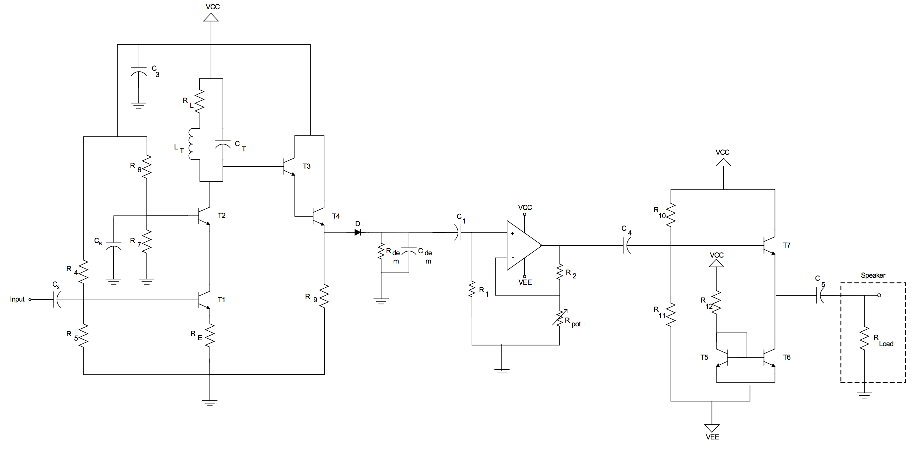

Figure 6.1: AM Receiver schematic

When connecting all circuits, the loading effect of each individual circuit must be considered. The loading effect is the input impedance of the subsequent stage, which acts as a load for the current stage. Theoretically, it would be ideal to have high input impedance and low output impedance for each of the different systems.

***Loading effect at first stage:***

If the input resistance of the next stage, Rin|stage2, isn’t large enough then the output resistance, Rout|stage1, will have an added resistance. The output voltage will decrease which in turn decreases the gain of the stage:

vout = iout ×( Rin|stage2 || Rout|stage1) (6.1)

However, if the input resistance of the next stage is much larger than output resistance, then its effect on the gain should be minimal.

***Loading effect at the second stage:***

The input resistance of the baseband amplifier is: Rin|baseband = R1 = 150kΩ

This changes output resistance of second stage to:

Rout|stage2 = Rout|demod || Rin|baseband (6.2)

The gain at the second stage is 1V/V. The added resistance at the output resistance will decrease the gain minimally.

The added impedance at the output will affect the time constant, ꞇ. Initially, time constant was:

ꞇ = Rdem × Cdem to ꞇ = Cdem × (Rdem || Rin|baseband) (6.3)

This decreases the time constant of the demodulator, thus resistance at the demodulator, Rdem, must be increased to compensate for this decrease.

***Loading effect at the third stage:***

The input resistance of Class A output stage is very high, and output resistance of the baseband amplifier is 0Ω. Thus, there will be no significant loading effect.

***Loading effect at the fourth stage:***

The load of this stage is an 8Ω speaker. This was taken into account when designing the output stage.

## Experiment

The circuit was assembled in Pspice and simulated. The following diagram shows the input and output.

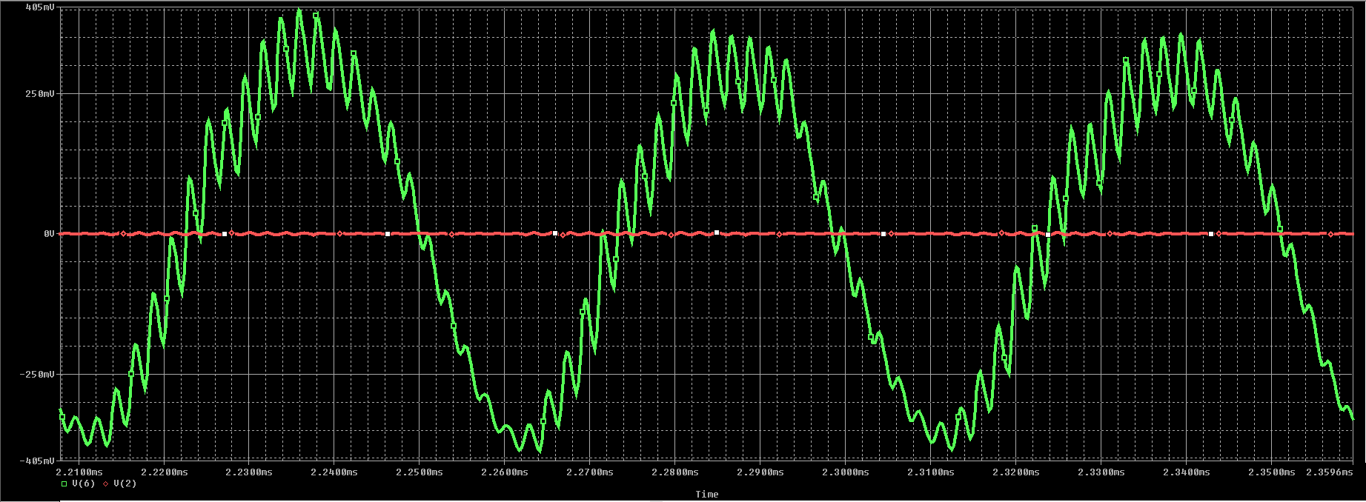

Figure 6.2: Psipce simulation of AM Receiver

The red line is the input, a modulated signal, with amplitude of 500uV.

The green curve is the output, with amplitude of 500mV

The simulated gain of the circuit is therefore 500mV/500µV = 1000 V/V

The circuit was assembled, and tested. Different baseband frequencies provided the different notes as per the table chart below:

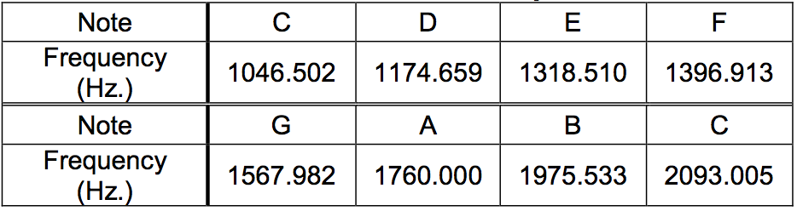

Table .1: Musical tone frequencies

The gain for the receiver was measured for 2 frequency values: Baseband and Carrier. **Table** in appendix shows the measured values. The yellow cells highlight the bandwidth of the circuit. The output for the baseband was calculated by setting the carrier frequency 1MHz and varying the baseband frequency from 0 – 20 kHz, the frequency range for hearing. The gain for the carrier frequency was measured in a similar fashion, by setting the baseband frequency to 1 kHz. The figure 5.3 below shows the output of the Receiver once it has stabilized for a baseband frequency of 5kHz. Figure 5.4 shows the output at resonant frequency of 480kHz. The two charts below compare the gain of the receiver for baseband and carrier frequencies.

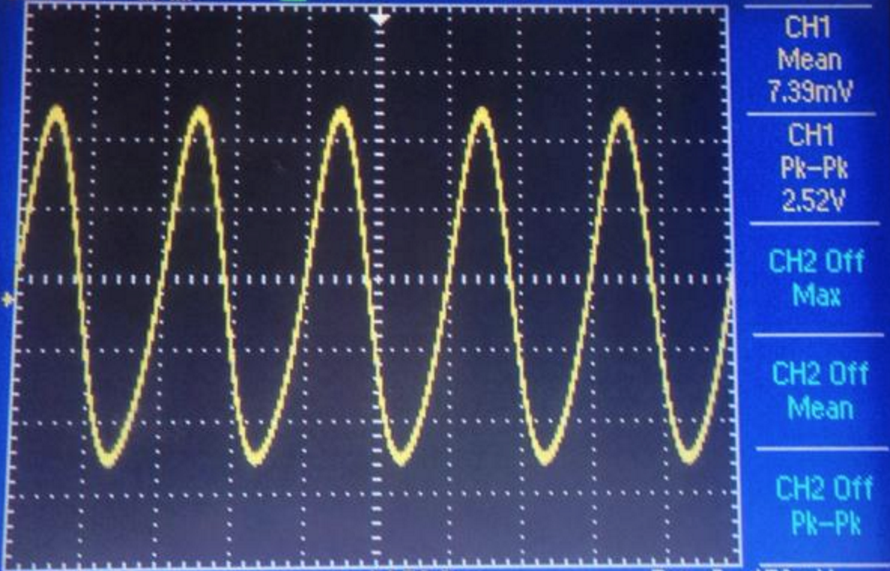

Figure .3: Output for baseband frequency: 5kHz



Figure .4: Output at resonant frequency: 480 kHz

The outputs were all measured, and used to calculate the gain for both the frequencies. The graphs below show the gain achieved:

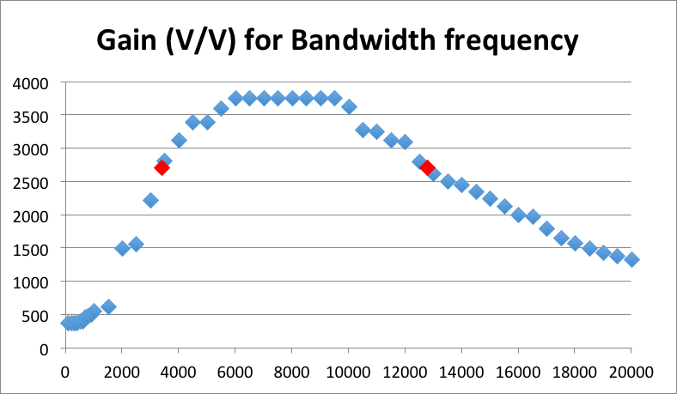

Figure .5: Gain for the receiver for a selection for baseband frequencies

The red markers on the graph are the high and low 3dB cutoff points. The gain for the circuit using baseband frequencies was calculated to be 3750 V/V.

The bandwidth is 9.4 kHz

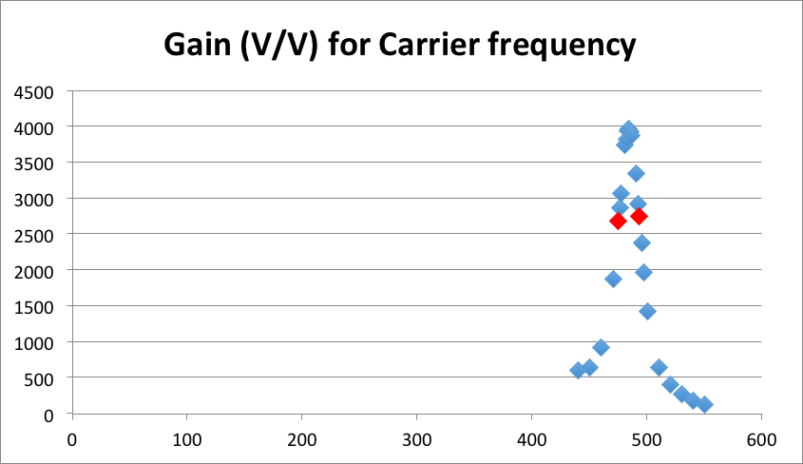

Figure .6: Gain for the receiver for a selection of carrier frequencies

The gain for the circuit was measured to be 3750 V/V at resonant frequency. The bandwidth was 40 kHz.

## Discussion

Because of loading effect of each stage, the components of the demodulator and preamplifier had to be modified. Other than that, the receiver functioned as expected. An antenna was connected to the input and a variable capacitor was used to listen to different radio stations. Since our assigned frequency was not a local AM radio channel, we had to change the tank elements to match the radio frequency of a local French radio station. The picture below shows the oscilloscope reading of the channel at 690 kHz. The table beside it shows local stations, and the respective capacitor values needed to tune into those stations for a constant inductor value of 100 uH.

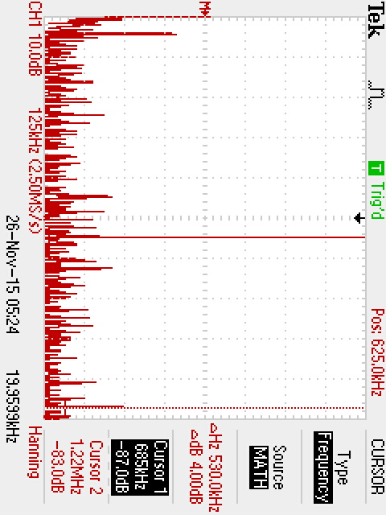 Table 6.2: Local stations and respective capacitance

Figure .7: Frequency of channel at 690 kHz

|  |  |  |  |
| --- | --- | --- | --- |
| **Station** | **Frequency (KHz)** | **Language** | **Capacitor** |
| WVMT | 620 | English | 6.58957E-09 |
| CINF | 690 | French | 5.32037E-09 |
| CKAC | 730 | French | 4.75329E-09 |
| CJAD | 800 | English | 3.95786E-09 |
| CINW | 940 | English | 2.86672E-09 |
| CKGM | 990 | English | 2.58446E-09 |
| CFMB | 1280 | Polyglot | 1.54604E-09 |
| WIRY | 1340 | English | 1.41069E-09 |
| CHOU | 1450 | Polyglot | 1.20477E-09 |
| CFAV | 1570 | French | 1.02764E-09 |

# CONCLUSION

This experiment has taken us through the different modules of an AM receiver, component by component. The figure below is the final product. The functioning of each individual stage in the proper functioning of the radio was explored. Though each stage could be successfully assembled and tested with relative ease, it was a challenge to combine them together and still generate expected signal. This is mainly due to the loading effect of each successive stage. This experiment also showed the importance frequency response of each stage affecting the overall frequency response of the system. In conclusion, this lab was a success, effectively allowing the students to apply the theory learned in previous courses.

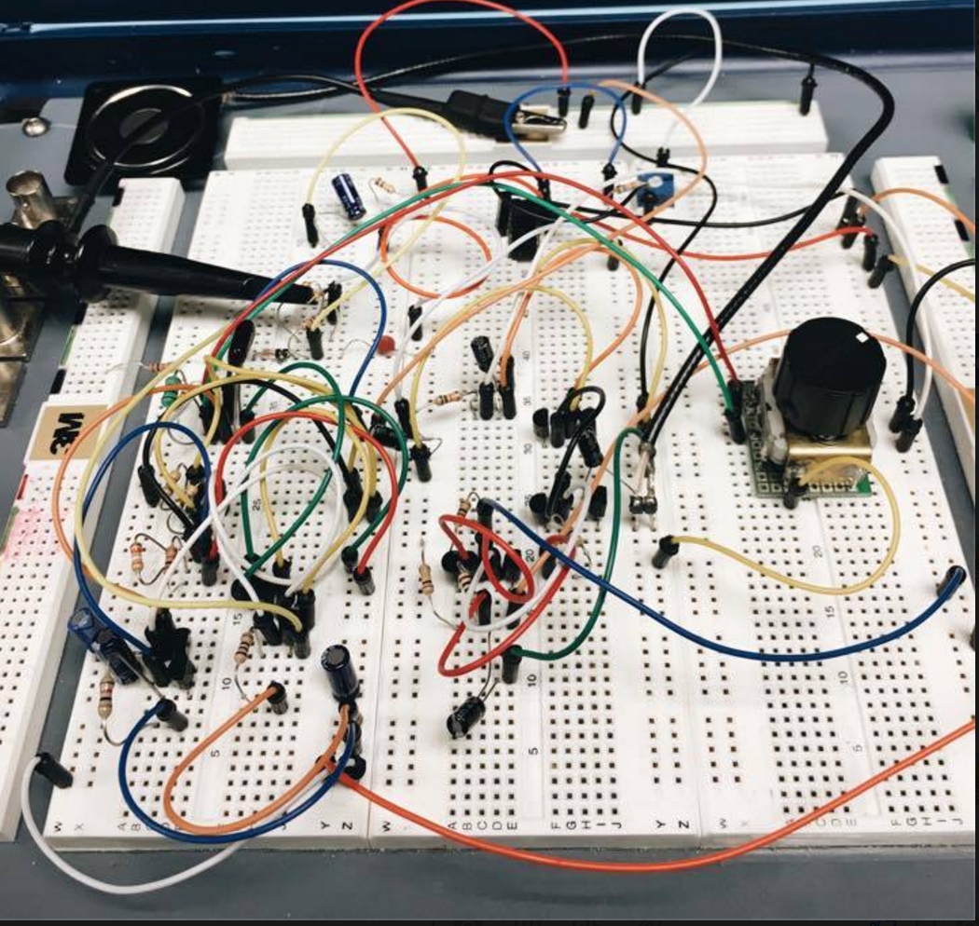

Figure .1: The AM Receiver of group 8

# LIST OF FIGURES

|  |  |
| --- | --- |
| Figure 1.1: System-level diagram of AM receiver | 3 |
| Figure 2.1: Baseband amplifier circuit | 4 |
| Figure 2.2: Frequency response for gain in V/V | 5 |
| Figure 2.3: Frequency response for gain in dB | 5 |
| Figure 2.4: Plot of gain in dB versus variable resistance | 5 |
| Figure 2.5: Plot of gain in dB versus variable resistance | 5 |
| Figure 2.6: Equivalent circuit for measuring input resistance | 6 |
| Figure 2.7: Spice simulation for baseband amplifier | 6 |
| Figure 3.1: High-level system diagram of AM demodulator | 7 |
| Figure 3.2: Waveform of input signal versus the output signal | 8 |
| Figure 3.3: Gain versus frequency baseband plot | 8 |
| Figure 3.4: Gain versus frequency plot | 8 |
| Figure 3.5: Pspice simulation for demodulator | 8 |
| Figure 4.1: Circuit schematic of Class A output | 10 |
| Figure 4.2: Graph showing cutoff voltages for a transistor | 10 |
| Figure 4.3: Small versus Large gain (dB) | 11 |
| Figure 5.1: Preamplifier circuit | 12 |
| Figure 5.2: Spice simulation of preamplifier | 13 |
| Figure 5.3: Voltage gain of preamplifier | 13 |
| Figure 6.1: AM Receiver schematic | 14 |
| Figure 6.2: Pspice simulation of AM receiver | 15 |
| Figure 6.3: Output for baseband frequency: 5kHz | 16 |
| Figure 6.4: Output at resonant frequency: 480 kHz | 16 |
| Figure 6.5: Gain for the receiver for a selection for baseband frequencies | 16 |
| Figure 6.6: Gain for the receiver for a selection of carrier frequencies | 17 |
| Figure 6.7: Frequency of channel at 690 kHz | 17 |
| Figure 7.1: The AM Receiver of group 8 | 18 |

# LIST OF TABLES

|  |  |
| --- | --- |
| Table 2.1: Spice versus experimental values of baseband amplifier | 6 |
| Table 3.1: Comparison of simulated and experimented values of demodulator | 8 |
| Table 4.1: Small versus Large signal cutoff and gain | 11 |
| Table 4.2: Spice versus Experimental values for class A output stage | 11 |
| Table 5.1: Values used in Pspice versus experiment for preamplifier | 13 |
| Table 6.1: Musical tone frequencies | 15 |
| Table 6.2: Local stations and respective capacitance | 17 |

# Appendix

Table 10.1: Values for frequency response of baseband amplifier

|  |  |  |  |  |
| --- | --- | --- | --- | --- |
| **Frequency (Hz)** | **Vin (V)** | **Vout (V)** | **Gain (V/V)** | **Gain (dB)** |
| 1 | 0.036 | 0.96 | 26.67 | 28.52 |
| 2 | 0.036 | 2.52 | 70.00 | 36.90 |
| 3 | 0.036 | 4.08 | 113.33 | 41.09 |
| 4 | 0.036 | 5 | 138.89 | 42.85 |
| 5 | 0.036 | 5.2 | 144.44 | 43.19 |
| 6 | 0.036 | 5.36 | 148.89 | 43.46 |
| 10 | 0.036 | 5.36 | 148.89 | 43.46 |
| 100 | 0.036 | 5.52 | 153.33 | 43.71 |
| 1000 | 0.036 | 5.52 | 153.33 | 43.71 |
| 10000 | 0.036 | 4.88 | 135.56 | 42.64 |
| 11000 | 0.036 | 4.8 | 133.33 | 42.50 |
| 12000 | 0.036 | 4.72 | 131.11 | 42.35 |
| 13000 | 0.036 | 4.56 | 126.67 | 42.05 |
| 14000 | 0.036 | 4.48 | 124.44 | 41.90 |
| 15000 | 0.036 | 4.4 | 122.22 | 41.74 |
| 16000 | 0.036 | 4.32 | 120.00 | 41.58 |
| 17000 | 0.036 | 4.16 | 115.56 | 41.26 |
| 18000 | 0.036 | 4.08 | 113.33 | 41.09 |
| 19000 | 0.036 | 4 | 111.11 | 40.92 |
| 20000 | 0.036 | 3.92 | 108.89 | 40.74 |
| 21000 | 0.036 | 3.84 | 106.67 | 40.56 |
| 22000 | 0.036 | 3.72 | 103.33 | 40.28 |
| 23000 | 0.036 | 3.6 | 100.00 | 40.00 |
| 24000 | 0.036 | 3.52 | 97.78 | 39.80 |
| 25000 | 0.036 | 3.44 | 95.56 | 39.61 |
| 30000 | 0.036 | 3.08 | 85.56 | 38.64 |
| 40000 | 0.036 | 2.48 | 68.89 | 36.76 |
| 50000 | 0.036 | 2.06 | 57.22 | 35.15 |
| 100000 | 0.036 | 1.11 | 30.83 | 29.78 |

Table 10.2: Variable Resistance versus gain for baseband amplifier

|  |  |  |  |  |
| --- | --- | --- | --- | --- |
| **Rpot(Ω)** | **Vin (V)** | **Vout (V)** | **Gain (V/V)** | **Gain (dB)** |
| 470 | 0.036 | 8 | 222.2222 | 46.93575 |
| 1000 | 0.036 | 6.84 | 190 | 45.57507 |
| 2200 | 0.036 | 3.4 | 94.44444 | 39.50353 |
| 3300 | 0.036 | 2.32 | 64.44444 | 36.18371 |
| 3900 | 0.036 | 1.96 | 54.44444 | 34.71907 |
| 4700 | 0.036 | 1.62 | 45 | 33.06425 |
| 5600 | 0.036 | 1.4 | 38.88889 | 31.79651 |
| 6800 | 0.036 | 1.16 | 32.22222 | 30.16311 |
| 8200 | 0.036 | 0.98 | 27.22222 | 28.69847 |
| 10000 | 0.036 | 0.832 | 23.11111 | 27.27642 |

Table 10.3: Baseband frequency versus gain for demodulator

|  |  |  |  |  |
| --- | --- | --- | --- | --- |
| **Baseband (HZ)** | **Vin (V)** | **Vout (V)** | **Gain (V/V)** | **Gain(dB)** |
| 20000 | 3.6 | 1.32 | 0.366667 | -8.71457 |
| 19000 | 3.6 | 1.32 | 0.366667 | -8.71457 |
| 18000 | 3.6 | 1.32 | 0.366667 | -8.71457 |
| 17000 | 3.6 | 1.32 | 0.366667 | -8.71457 |
| 16000 | 3.6 | 1.32 | 0.366667 | -8.71457 |
| 15000 | 3.6 | 1.32 | 0.366667 | -8.71457 |
| 14000 | 3.6 | 1.32 | 0.366667 | -8.71457 |
| 13000 | 3.6 | 1.32 | 0.366667 | -8.71457 |
| 12000 | 3.6 | 1.32 | 0.366667 | -8.71457 |
| 11000 | 3.6 | 1.32 | 0.366667 | -8.71457 |
| 10000 | 3.6 | 1.36 | 0.377778 | -8.45527 |
| 9000 | 3.6 | 1.36 | 0.377778 | -8.45527 |
| 8000 | 3.6 | 1.36 | 0.377778 | -8.45527 |
| 7000 | 3.6 | 1.36 | 0.377778 | -8.45527 |
| 6000 | 3.6 | 1.36 | 0.377778 | -8.45527 |
| 5000 | 3.6 | 1.36 | 0.377778 | -8.45527 |
| 4000 | 3.6 | 1.36 | 0.377778 | -8.45527 |
| 3000 | 3.6 | 1.36 | 0.377778 | -8.45527 |
| 2000 | 3.6 | 1.36 | 0.377778 | -8.45527 |
| 1000 | 3.6 | 1.32 | 0.366667 | -8.71457 |

Table 10.4: Carrier frequency response versus gain of demodulator

|  |  |  |  |  |
| --- | --- | --- | --- | --- |
| **Carrier (kHz)** | **Vin (V)** | **Vout (V)** | **Gain (V/V)** | **Gain (dB)** |
| 200 | 3.6 | 1.48 | 0.411111 | -7.72082 |
| 300 | 3.6 | 1.4 | 0.388889 | -8.20349 |
| 400 | 3.6 | 1.32 | 0.366667 | -8.71457 |
| 500 | 3.6 | 1.28 | 0.355556 | -8.98185 |
| 600 | 3.6 | 1.26 | 0.35 | -9.11864 |
| 700 | 3.6 | 1.24 | 0.344444 | -9.25762 |
| 800 | 3.6 | 1.24 | 0.344444 | -9.25762 |
| 900 | 3.6 | 1.24 | 0.344444 | -9.25762 |
| 1000 | 3.6 | 1.24 | 0.344444 | -9.25762 |
| 1100 | 3.6 | 1.24 | 0.344444 | -9.25762 |
| 1200 | 3.6 | 1.24 | 0.344444 | -9.25762 |

Table 10.5: Frequency response of preamplifier

|  |  |  |  |  |
| --- | --- | --- | --- | --- |
| Frequency (KHz) | Vin (mV) | Vout (mV) | Gain (V/V) | Gain (dB) |
| 100 | 2 | 25 | 12.5 | 21.93820026 |
| 420 | 2 | 44 | 22 | 26.84845362 |
| 430 | 2 | 44 | 22 | 26.84845362 |
| 440 | 2 | 54 | 27 | 28.62727528 |
| 450 | 2 | 56 | 28 | 28.94316063 |
| 460 | 2 | 64 | 32 | 30.10299957 |
| 470 | 2 | 84 | 42 | 32.46498581 |
| 475 | 2 | 98 | 49 | 33.8039216 |
| 480 | 2 | 120 | 60 | 35.56302501 |
| 485 | 2 | 154 | 77 | 37.7298145 |
| 490 | 2 | 166 | 83 | 38.38156185 |
| 495 | 2 | 134 | 67 | 36.52149605 |
| 500 | 2 | 106 | 53 | 34.48551739 |
| 505 | 2 | 88 | 44 | 32.86905353 |
| 510 | 2 | 76 | 38 | 31.59567193 |
| 520 | 2 | 62 | 31 | 29.82723388 |
| 530 | 2 | 54 | 27 | 28.62727528 |
| 540 | 2 | 50 | 25 | 27.95880017 |
| 550 | 2 | 44 | 22 | 26.84845362 |
| 600 | 2 | 44 | 22 | 26.84845362 |

Table 10.6: Gain for Baseband frequency

|  |  |  |  |  |
| --- | --- | --- | --- | --- |
| **Frequency (Hz)** | **Vin (mV)** | **Vout (mV)** | **Gain (V/V)** | **Gain (dB)** |
| 100 | 0.8 | 300 | 375 | 51.48062535 |
| 200 | 0.8 | 300 | 375 | 51.48062535 |
| 300 | 0.8 | 300 | 375 | 51.48062535 |
| 400 | 0.8 | 300 | 375 | 51.48062535 |
| 500 | 0.8 | 320 | 400 | 52.04119983 |
| 600 | 0.8 | 320 | 400 | 52.04119983 |
| 700 | 0.8 | 370 | 462.5 | 53.30223474 |
| **800** | **0.8** | **380** | **475** | **53.53387219** |
| 900 | 0.8 | 408 | 510 | 54.15140352 |
| 1000 | 0.8 | 440 | 550 | 54.80725379 |
| 1500 | 0.8 | 500 | 625 | 55.91760035 |
| 2000 | 0.8 | 1200 | 1500 | 63.52182518 |
| 2500 | 0.8 | 1250 | 1562.5 | 63.87640052 |
| 3000 | 0.8 | 1780 | 2225 | 66.94660031 |
| 3400 | 0.8 | 2160 | 2700 | 68.62727528 |
| 3500 | 0.8 | 2250 | 2812.5 | 68.98185062 |
| **4000** | **0.8** | **2500** | **3125** | **69.89700043** |
| 4500 | 0.8 | 2720 | 3400 | 70.62957834 |
| 5000 | 0.8 | 2720 | 3400 | 70.62957834 |
| 5500 | 0.8 | 2880 | 3600 | 71.12605002 |
| 6000 | 0.8 | 3000 | 3750 | 71.48062535 |
| 6500 | 0.8 | 3000 | 3750 | 71.48062535 |
| 7000 | 0.8 | 3000 | 3750 | 71.48062535 |
| 7500 | 0.8 | 3000 | 3750 | 71.48062535 |
| **8000** | **0.8** | **3000** | **3750** | **71.48062535** |
| 8500 | 0.8 | 3000 | 3750 | 71.48062535 |
| 9000 | 0.8 | 3000 | 3750 | 71.48062535 |
| 9500 | 0.8 | 3000 | 3750 | 71.48062535 |
| **10000** | **0.8** | **2900** | **3625** | **71.18616022** |
| 10500 | 0.8 | 2620 | 3275 | 70.30422609 |
| 11000 | 0.8 | 2600 | 3250 | 70.23766722 |
| 11500 | 0.8 | 2500 | 3125 | 69.89700043 |
| 12000 | 0.8 | 2480 | 3100 | 69.82723388 |
| 12500 | 0.8 | 2240 | 2800 | 68.94316063 |
| 12800 | 0.8 | 2160 | 2700 | 68.62727528 |
| 13000 | 0.8 | 2100 | 2625 | 68.38258615 |
| 13500 | 0.8 | 2000 | 2500 | 67.95880017 |
| 14000 | 0.8 | 1960 | 2450 | 67.78332169 |
| 14500 | 0.8 | 1880 | 2350 | 67.42135725 |
| 15000 | 0.8 | 1800 | 2250 | 67.04365036 |
| 15500 | 0.8 | 1700 | 2125 | 66.54717869 |
| 16000 | 0.8 | 1600 | 2000 | 66.02059991 |
| **16500** | **0.8** | **1580** | **1975** | **65.911342** |
| 17000 | 0.8 | 1440 | 1800 | 65.1054501 |
| 17500 | 0.8 | 1320 | 1650 | 64.34967888 |
| 18000 | 0.8 | 1260 | 1575 | 63.94561116 |
| 18500 | 0.8 | 1200 | 1500 | 63.52182518 |
| 19000 | 0.8 | 1150 | 1437.5 | 63.15215707 |
| 19500 | 0.8 | 1100 | 1375 | 62.76605396 |
| **20000** | **0.8** | **1060** | **1325** | **62.44431757** |

Table 10.7: Gain for carrier frequency

|  |  |  |  |  |
| --- | --- | --- | --- | --- |
| **Frequency (kHz)** | **Vin (mV)** | **Vout (mV)** | **Gain (V/V)** | **Gain (dB)** |
| **440** | **0.8** | **480** | **600** | **55.56302501** |
| 450 | 0.8 | 512 | 640 | 56.12359948 |
| 460 | 0.8 | 736 | 920 | 59.27575655 |
| 470 | 0.8 | 1500 | 1875 | 65.46002544 |
| 475 | 0.8 | 2140 | 2675 | 68.54647573 |
| 476 | 0.8 | 2300 | 2875 | 69.17275698 |
| 477 | 0.8 | 2460 | 3075 | 69.7569024 |
| **480** | **0.8** | **3000** | **3750** | **71.48062535** |
| 482 | 0.8 | 3060 | 3825 | 71.65262879 |
| 483 | 0.8 | 3160 | 3950 | 71.93194191 |
| **484** | **0.8** | **3180** | **3975** | **71.98674266** |
| 485 | 0.8 | 3140 | 3925 | 71.87679322 |
| 486 | 0.8 | 3100 | 3875 | 71.76543414 |
| 490 | 0.8 | 2680 | 3350 | 70.50089614 |
| 492 | 0.8 | 2340 | 2925 | 69.32251741 |
| 493 | 0.8 | 2200 | 2750 | 68.78665388 |
| 495 | 0.8 | 1900 | 2375 | 67.51327228 |
| 497 | 0.8 | 1580 | 1975 | 65.911342 |
| **500** | **0.8** | **1140** | **1425** | **63.07629729** |
| 510 | 0.8 | 520 | 650 | 56.25826713 |
| 520 | 0.8 | 320 | 400 | 52.04119983 |
| 530 | 0.8 | 220 | 275 | 48.78665388 |
| 540 | 0.8 | 140 | 175 | 44.86076097 |
| **550** | **0.8** | **106** | **132.5** | **42.44431757** |